# **Background:**

Our project deals with observing frequency response of a power system and applying appropriate load shedding scheme based on certain criterions. In order to obtain our objectives, we will have to perform load flow analysis, transient response analysis, frequency response analysis and apply load shedding schemes.

Power flow analysis gives us all the bus voltages, all the real and reactive power flow through all the lines of a power system.

The frequency response of a power system refers to how the system's frequency varies in response to changes in load demand, generation output, or disturbances. It is typically represented graphically as a frequency response curve (FRC), which shows how the system frequency deviates from its nominal value over time. Frequency stability, on the other hand, refers to the ability of a power system to maintain its nominal frequency within acceptable limits under various operating conditions.

Frequency stability is often assessed by analyzing parameters such as the frequency response curve, nadir (lowest frequency reached during disturbances), the rate of change of frequency (ROCF), and the system's response to transient events.

When load demand in the power system suddenly increases, according to the swing equation, the rotor decelerates and frequency decreases. To maintain synchronism and keep frequency deviation at tolerable limits, we have to apply load shedding schemes.

# **Objectives:**

* Making network using tabular format
* Performing load flow analysis
* Performing transient stability analysis for certain generator outage
* Observing frequency response curves
* Calculating FVSI for all the lines between buses
* Applying load shedding schemes based on the calculated FVSI
* Observing the impacts of load frequency relief

# **Test System:**

The IEEE 39-Bus system, also known as the New England Power System or the 10-machine 39-bus system, is a standard test system used for power system research and analysis. It represents a simplified version of the power network of the New England area and is widely used for studies related to power system stability, control, and reliability. The system consists of 39 buses (nodes), 10 generators, 19 loads, and 46 transmission lines. It is designed to simulate the behavior and dynamics of a real power grid, making it suitable for testing various algorithms and techniques in power system analysis. We applied each of the loads to a designated bus, the total of which comprises 6097.1 MW of real power and 1408.9 MW of reactive power. Bus 31 is typically designated as the slack bus, which balances the active and reactive power in the system and buses with generators include 30, 31, 32, 33, 34, 35, 36, 37, 38, and 39. These buses are equipped with generating units that have specific generating voltages.

# **Methodology:**

## **Creating the Network:**

The network was created in PSAF software using the tabular method for entering data. From our given power system data, we entered the bus data in kV. Line data were entered in per unit per km. Transformer high voltage and low voltage data were in kV and resistance and reactance were entered in pu. Generator data were entered in pu and their dispatched real power was in MW units. Our created different component data tables are shown below:

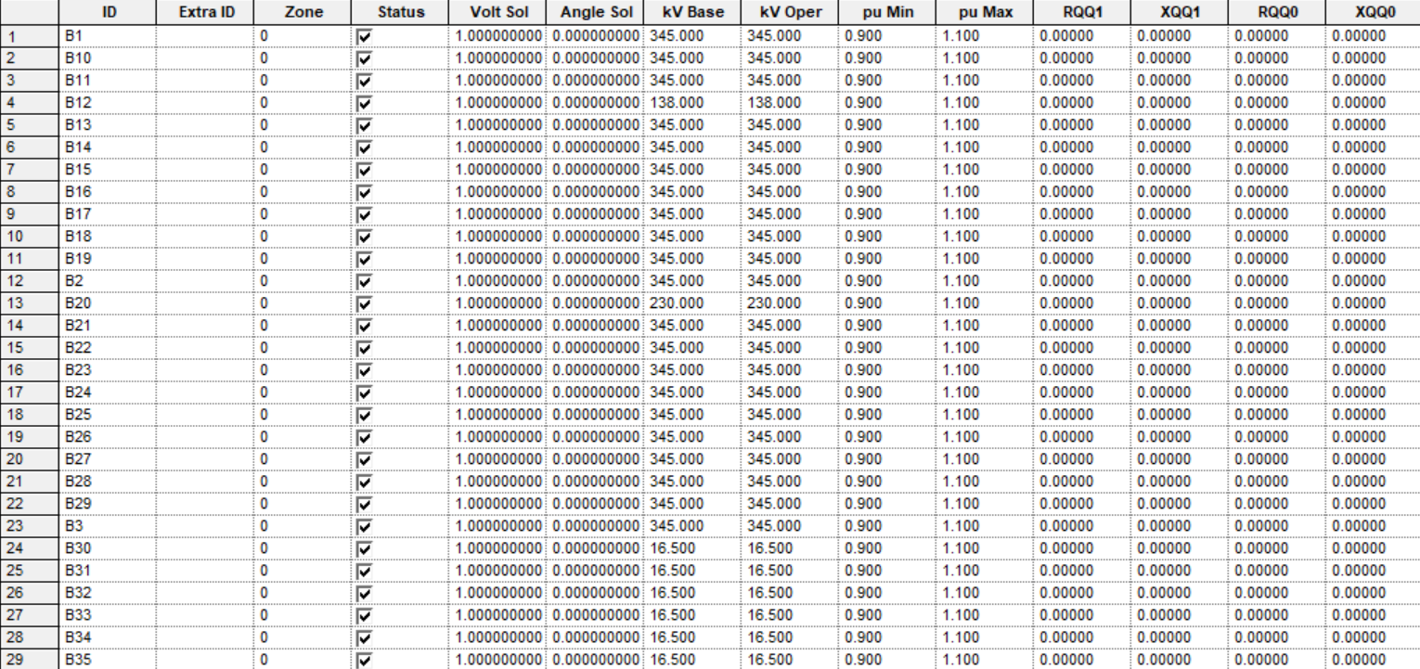

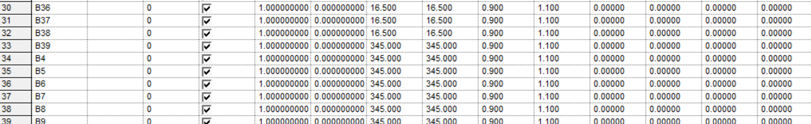

Fig: 01 (Bus Table)

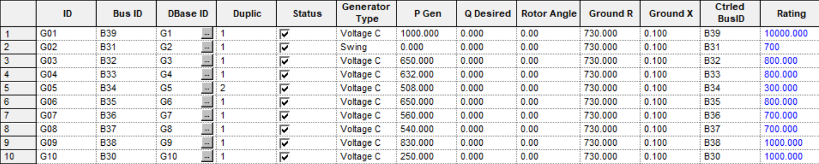

Fig:02 (Generator Table)

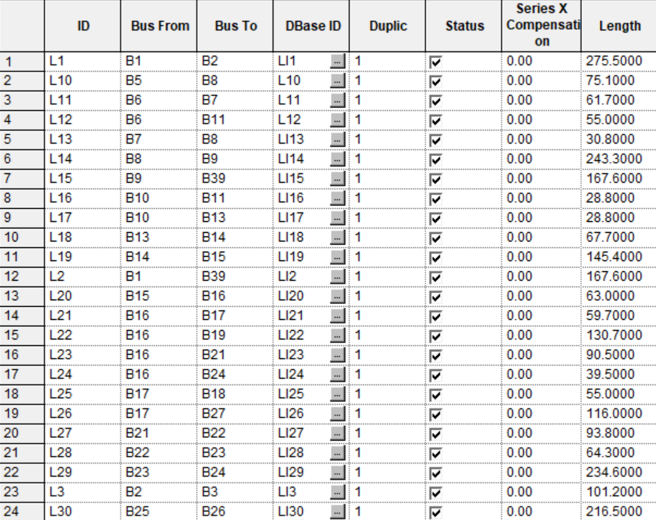

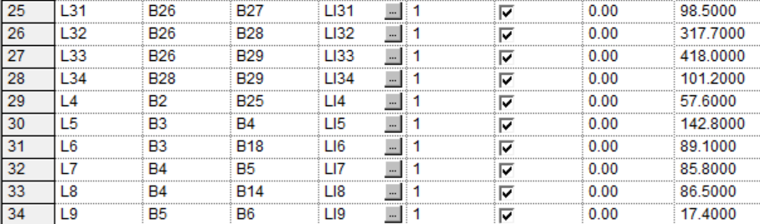

Fig: 03 (Line Table)

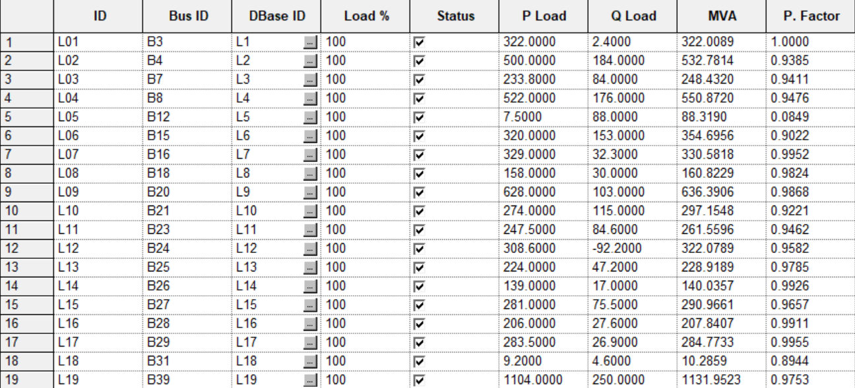

Fig: 04 (Load Table)

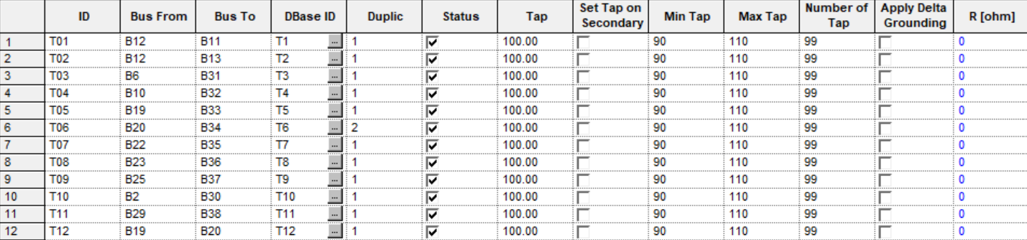

Fig: 05 (Transformer Table)

## **Performing Load flow analysis:**

After preparing all the tables, we performed load flow analysis. We used Newton Raphson method for making the load flow analysis. This load flow analysis yielded the resulting bus voltages and real and reactive power flow through all the lines.

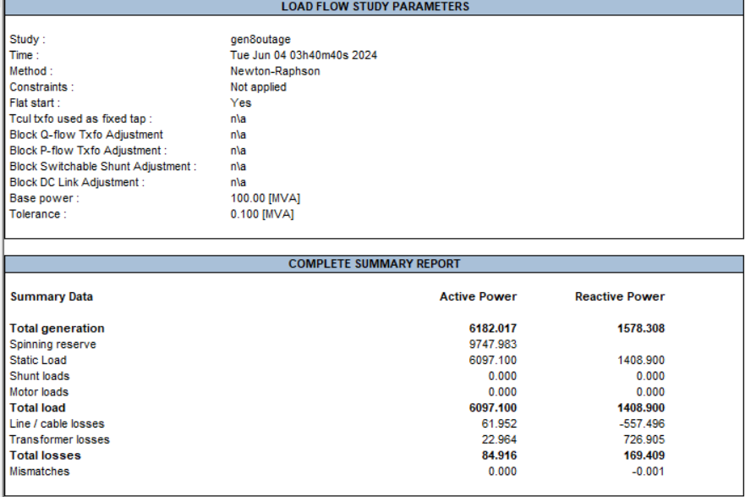

Fig: 06

## **Making CSV file for the obtained load flow analysis Data and Calculating FVSI:**

After getting the bus voltages and line flows, all those obtained data were used to prepare a CSV file which contained information of line resistance and reactance, between which buses the lines are collected, the bus voltage, reactive power flow. This CSV file will be later used to calculate FVSI for all the lines using MATLAB. The MATLAB script for calculating FVSI is attached with all the project files. Formula for FVSI is:

FVSIi,j = (4 Zij2 Qij ) / (Vi2 Xij)

Firstly, the CSV file was imported in MATLAB, then we prepared a script which will parse all the data required for calculating the FVSI. Then it will return a matrix with 3 columns where the first column will represent the sending bus, 2nd column is the receiving bus and the last column is the calculated FVSI.

|  |  |  |  |  |  |  |  |
| --- | --- | --- | --- | --- | --- | --- | --- |
| **From** | **To** | **V** | **Q** | **R** | **X** | **FVSI** | **load connection** |
| B10 | B11 | 0.973 | -32 | 0.0004 | 0.0043 | 3.0867 | Absent |
| B6 | B11 | 0.945 | 104.78 | 0.0007 | 0.0082 | 1.867 | Absent |
| B10 | B13 | 0.973 | 119.19 | 0.0004 | 0.0043 | 0.5864 | Absent |
| B13 | B14 | 0.968 | 86.45 | 0.0009 | 0.0101 | 2.1842 | Absent |
| B4 | B14 | 0.944 | -62.32 | 0.0008 | 0.0129 | 3.7569 | Absent |
| B14 | B15 | 0.957 | 35.25 | 0.0018 | 0.0217 | 3.3638 | Present |
| B15 | B16 | 0.952 | -108.4 | 0.0009 | 0.0094 | 4.5384 | Present |
| B16 | B17 | 0.968 | -153.87 | 0.0008 | 0.0135 | 8.8986 | Absent |
| B17 | B18 | 0.98 | 19.3 | 0.0013 | 0.0173 | 1.984 | Present |
| B3 | B18 | 0.973 | -4.95 | 0.0011 | 0.0133 | 2.442 | Present |
| B16 | B19 | 0.968 | 78.57 | 0.0003 | 0.0059 | 12.4933 | Absent |
| B1 | B2 | 1.004 | 18.79 | 0.0035 | 0.0411 | 1.3985 | Absent |
| B16 | B21 | 0.968 | 63.88 | 0.0007 | 0.0089 | 6.4351 | Present |
| B21 | B22 | 0.963 | -45.66 | 0.0008 | 0.014 | 5.6103 | Absent |
| B22 | B23 | 0.98 | 28.43 | 0.0006 | 0.0096 | 1.4943 | Present |
| B16 | B24 | 0.968 | -149.08 | 0.0016 | 0.0195 | 2.7662 | Present |
| B23 | B24 | 0.976 | -12.02 | 0.0022 | 0.035 | 1.1412 | Present |
| B2 | B25 | 0.991 | 25.66 | 0.007 | 0.0086 | 1.7736 | Present |
| B25 | B26 | 0.991 | -29.27 | 0.0032 | 0.0323 | 3.8885 | Present |
| B17 | B27 | 0.98 | -187.06 | 0.0007 | 0.0082 | 13.7542 | Present |
| B26 | B27 | 0.994 | 53.91 | 0.0057 | 0.0625 | 5.6843 | Present |
| B26 | B28 | 0.994 | -29.38 | 0.0043 | 0.0474 | 2.0496 | Present |
| B26 | B29 | 0.994 | -34.13 | 0.0014 | 0.0147 | 1.2596 | Present |
| B28 | B29 | 0.995 | 20.47 | 0.0014 | 0.0151 | 8.7538 | Present |
| B2 | B3 | 0.991 | 90.55 | 0.0013 | 0.0151 | 0.2801 | Present |
| B1 | B39 | 1.004 | -18.79 | 0.001 | 0.025 | 0.7319 | Present |
| B9 | B39 | 0.98 | -84.65 | 0.001 | 0.025 | 3.6224 | Present |
| B3 | B4 | 0.973 | 96.91 | 0.0013 | 0.0213 | 2.1642 | Present |
| B4 | B5 | 0.944 | -12.69 | 0.0008 | 0.0128 | 0.4547 | Absent |
| B5 | B6 | 0.944 | -38.73 | 0.0002 | 0.0026 | 2.7446 | Absent |
| B6 | B7 | 0.945 | 66.32 | 0.0006 | 0.0092 | 3.8765 | Present |
| B5 | B8 | 0.944 | 42.83 | 0.0008 | 0.0112 | 0.3856 | Present |
| B7 | B8 | 0.936 | -18.22 | 0.0004 | 0.0046 | 21.7885 | Present |
| B8 | B9 | 0.936 | -130.94 | 0.0023 | 0.0363 | 8.8281 | Absent |

## **Performing Transient Stability analysis:**

Transient stability studies are essential for assessing a power system's ability to maintain synchronism and stable operation following major disturbances such as generation loss, line-switching operations, faults, and sudden load changes. After obtaining the converged results from the power flow analysis, we perform frequency stability analysis in particular based on generator outage of G08. We implement the default load shedding scheme

## **Observing Frequency response curves:**

### **For default load frequency relief:**

In case of UFLS setting we used the following setting:

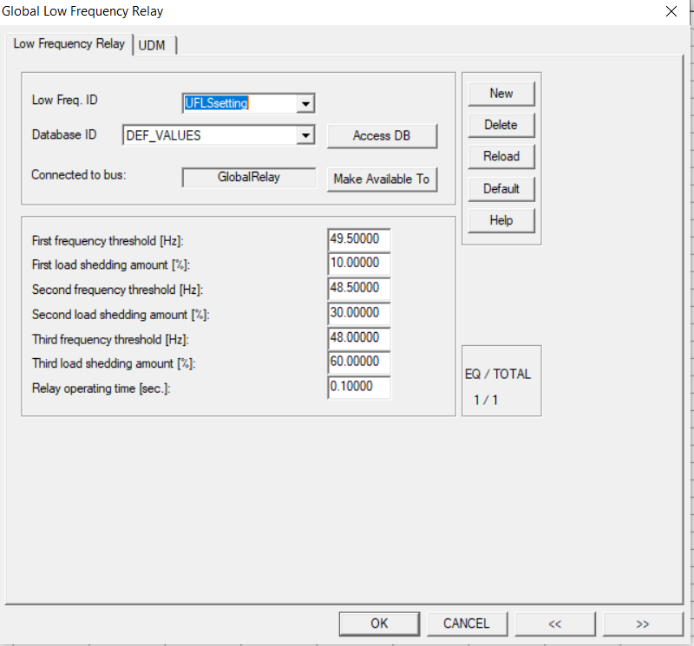

Fig: 07

### 

The following result was generated:

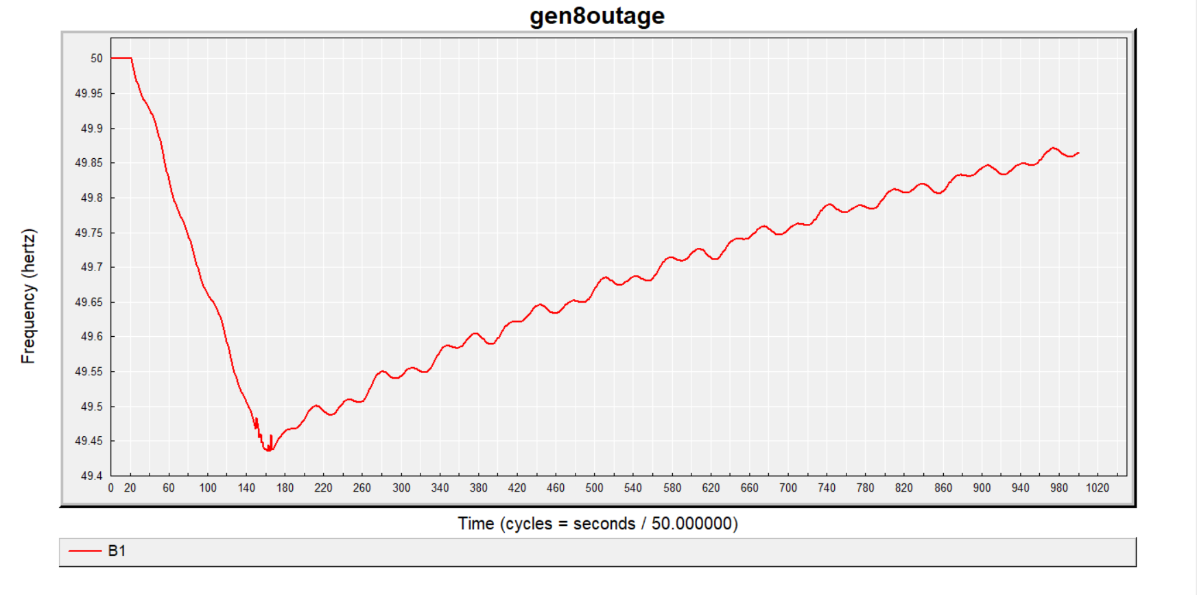

Fig: 08

Here we can observe that the nadir point approximately corresponds to 49.420 Hz. The system frequency linearly increases after shedding the load and will reach stability after a long time.

Next we used the same load shedding model but with the implementation of the parameter known as Frequency Relief (Kp):

### **For default load frequency relief of 1% :**

The following result was generated:

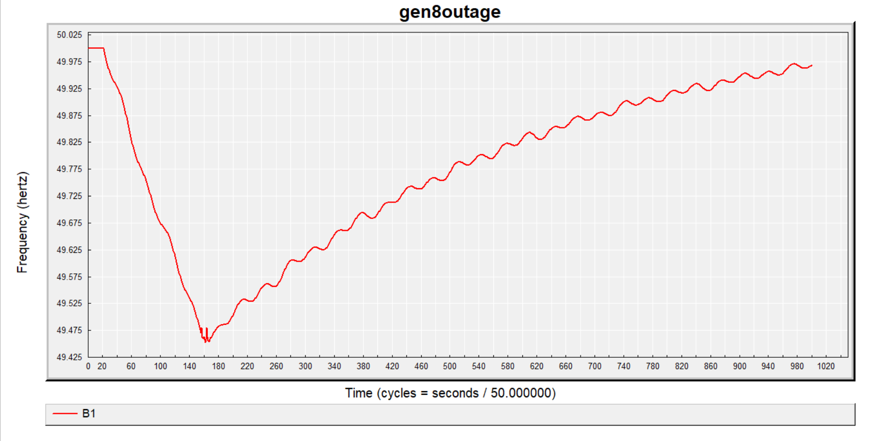

Fig: 09

In this case, the nadir point approximately corresponds to a frequency of 49.435 Hz, meaning that the nadir point slightly improves than the previous case (when Kp=0). Another important thing to note is that the frequency curve now, rather than increasing in a linear fashion, increases in a slightly nonlinear manner indicating that a stable frequency will be achieved sooner than before.

### **For default load frequency relief of 2% :**

The following result was generated:

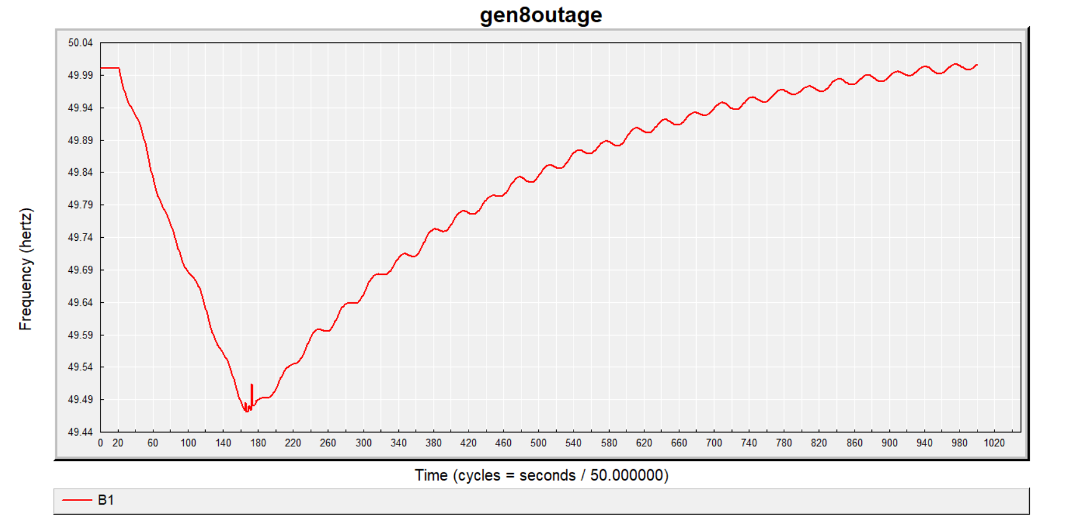

Fig: 10

In this case, the nadir point approximately corresponds to a frequency of 49.460 Hz, meaning that the nadir point improves further. The frequency curve increases in a more nonlinear fashion indicating that a stable frequency will be achieved even sooner.

### **For default load frequency relief of 3% :**

The following result was generated:

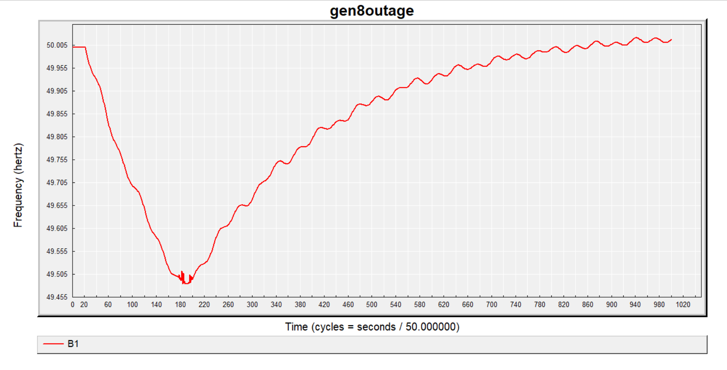

Fig: 11

The nadir point here corresponds to a frequency of 49.465 Hz. In this case, the nadir point improves even further and the time taken for reaching stable frequency reduces than the previous two cases.

Deduction: From the tuning of the Frequency Relief (Kp) parameter, i.e. by increasing the percentage Kp, the nadir point ever so slightly tends to improve and so does the time taken for reaching a stable frequency point. Hence this parameter can be compared with the differential operator of a PID controller which helps to improve transient characteristics (i.e. reach stability faster).

.

### **For FVSI LOAD SHEDDING SCHEME:**

### **Load Flow analysis report of the five zones:**

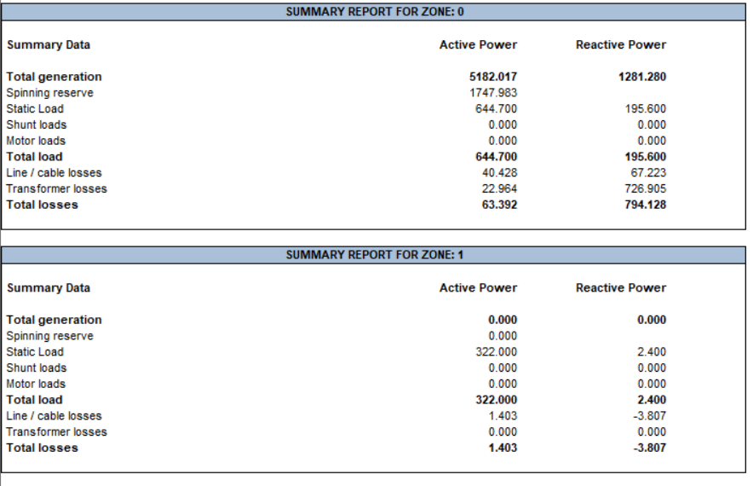

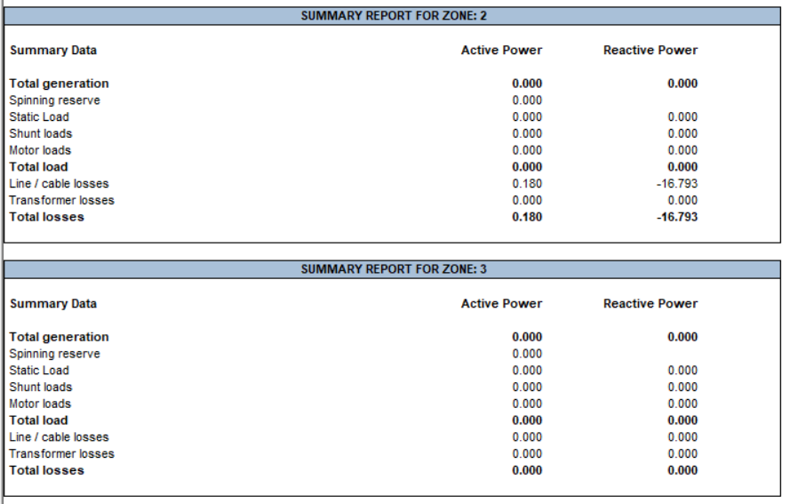

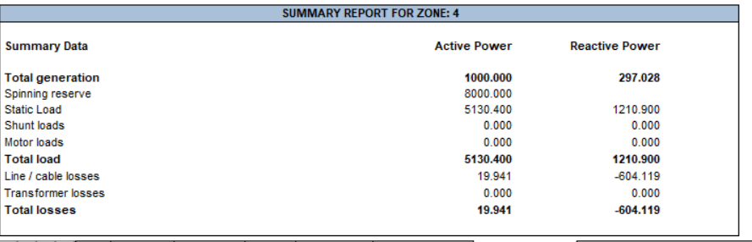

Fig:12

### **For default load frequency relief Kp=0:**

Zone-0

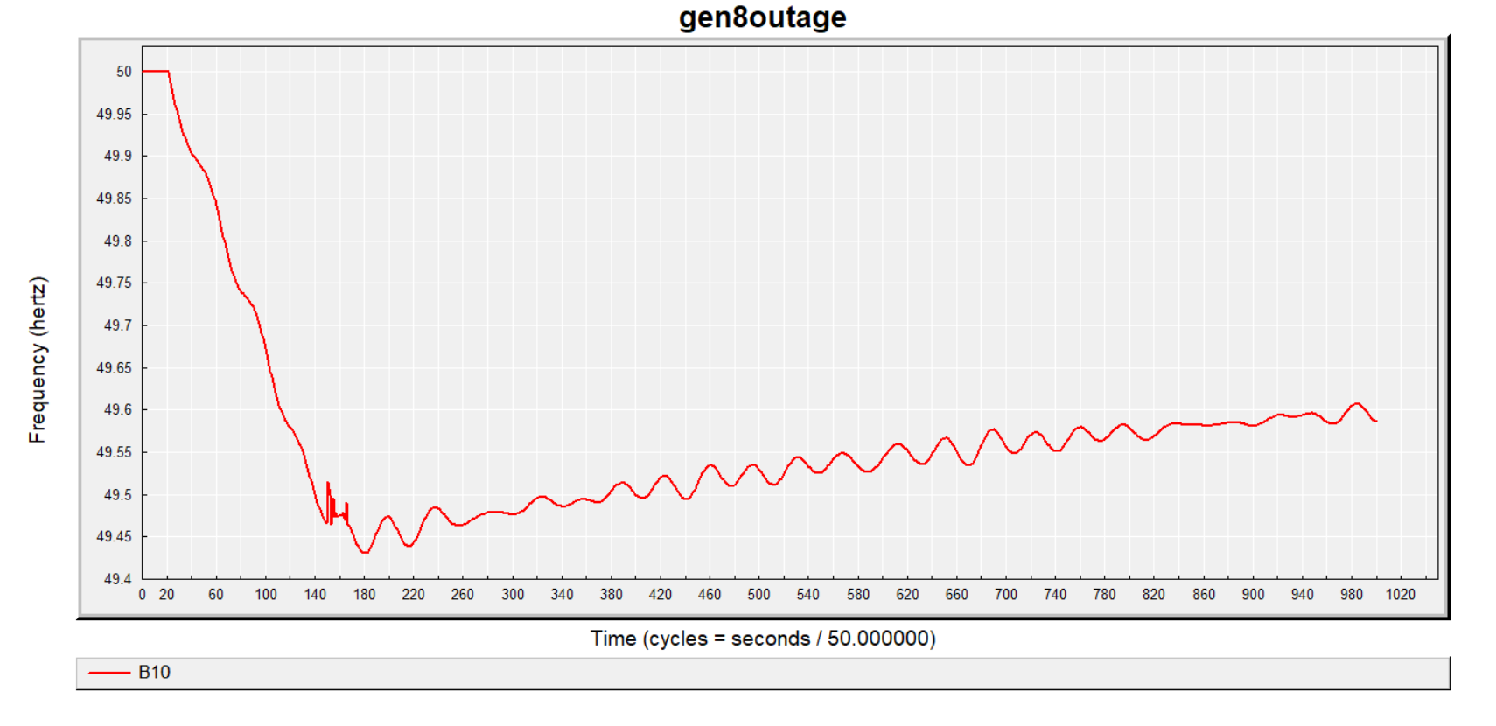

Fig: 13

Zone-1

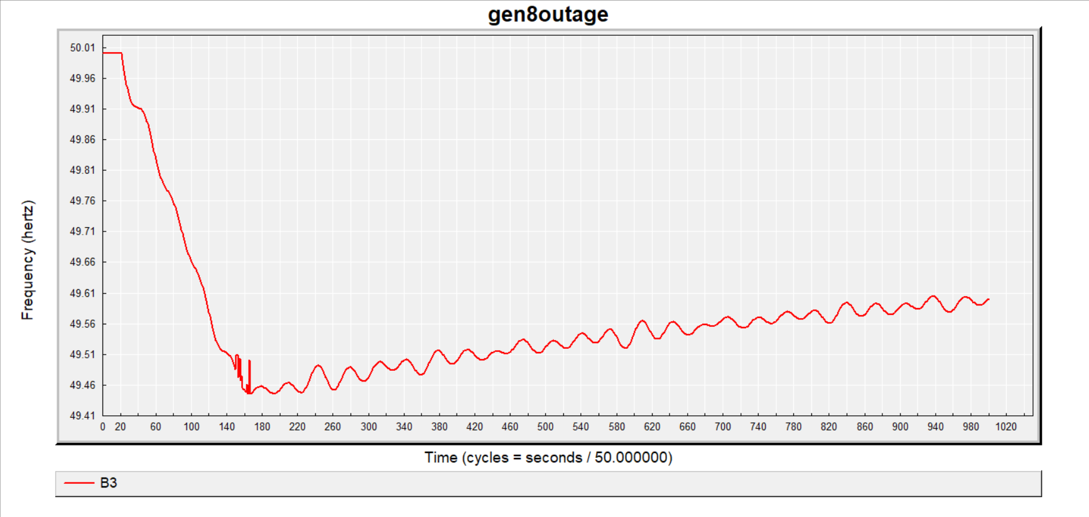

Fig:14

Zone-2

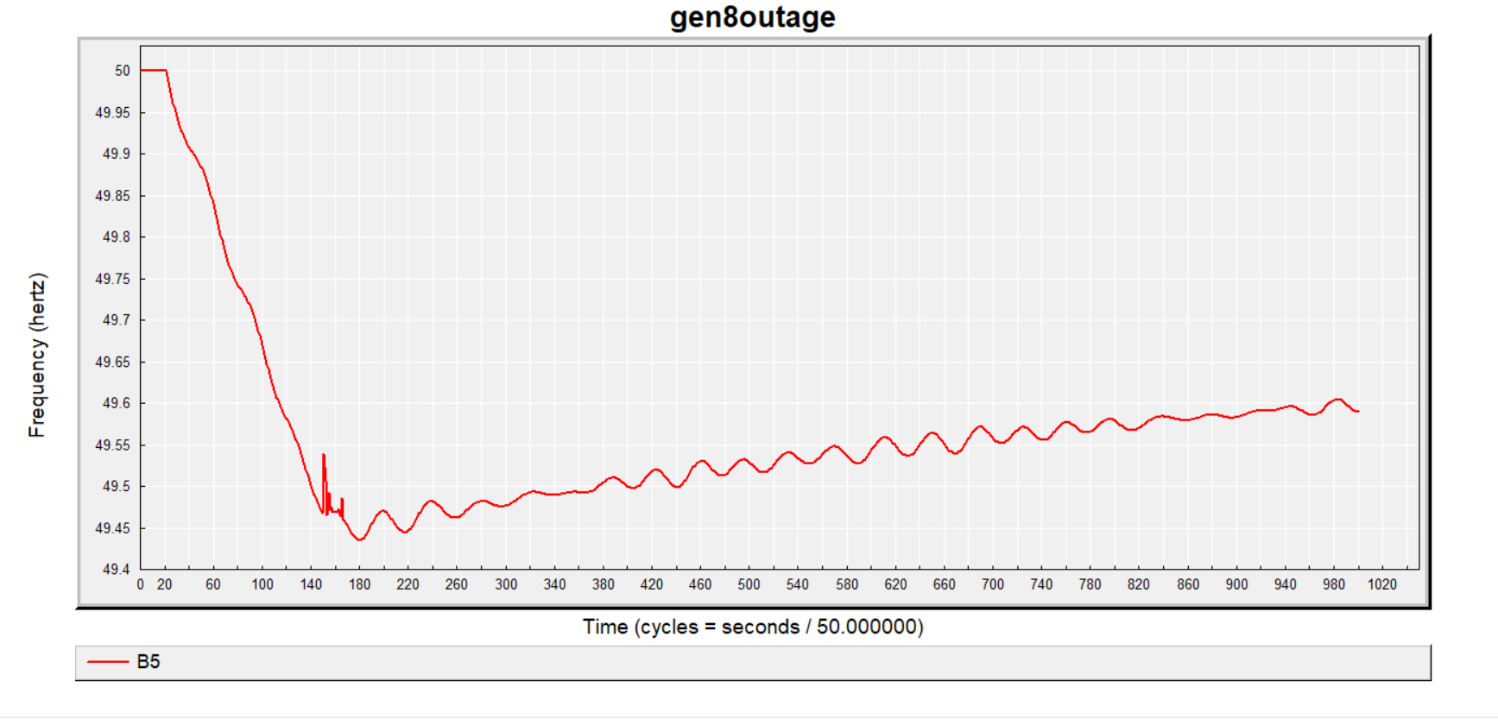

Fig: 15

Zone-3

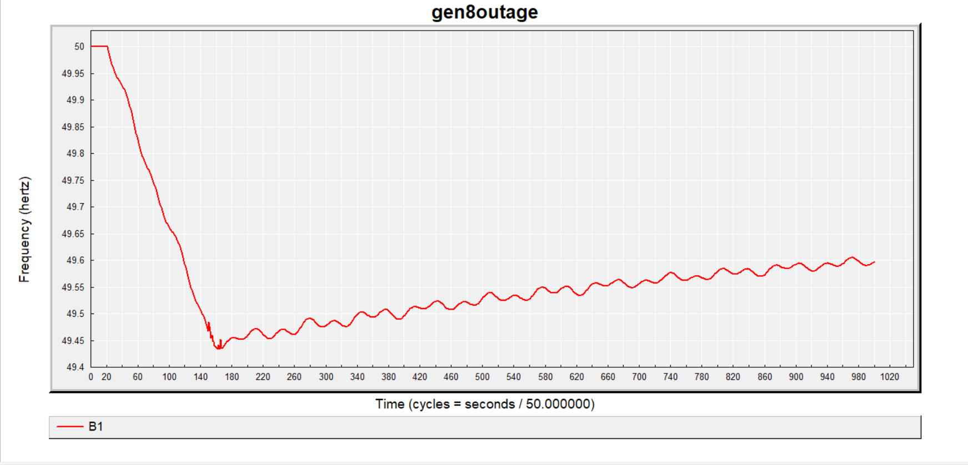

Fig: 16

Zone-4

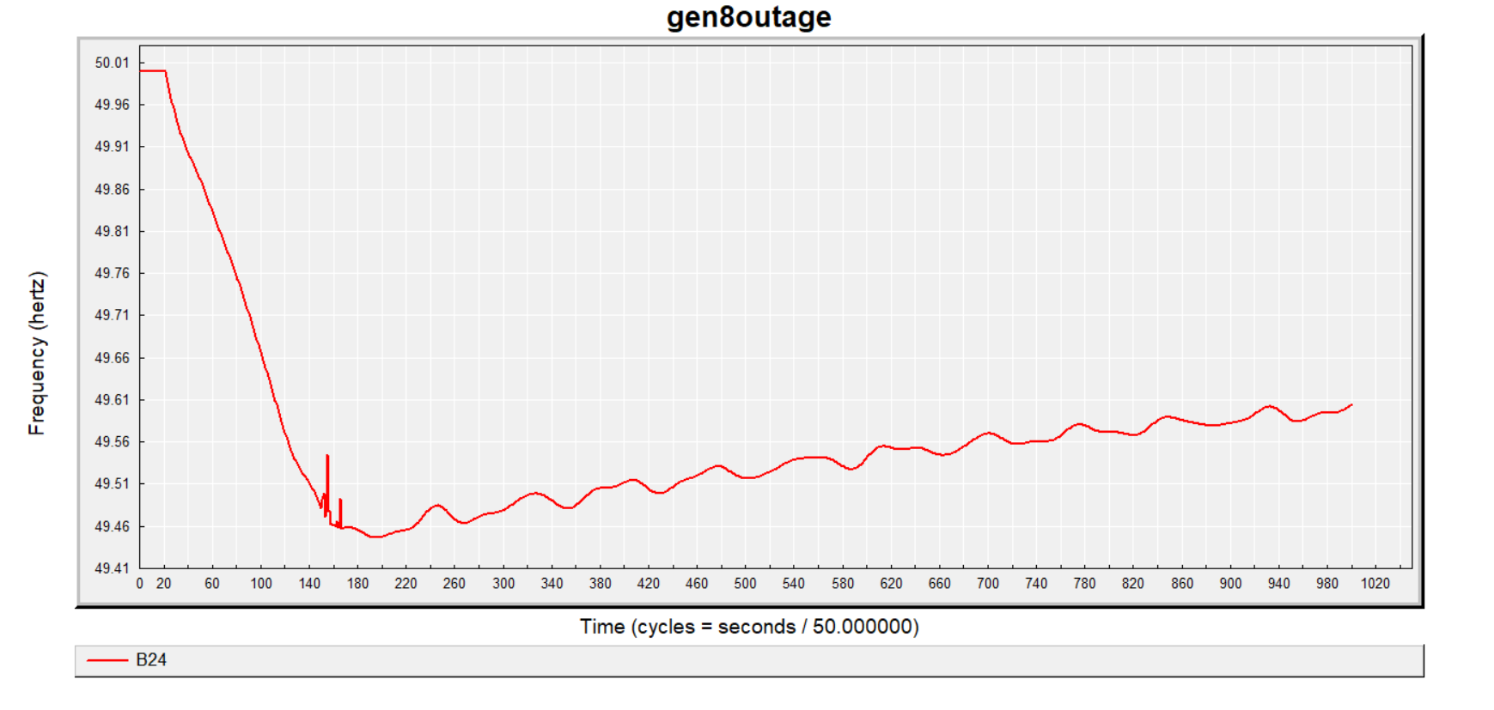

Fig:17

### **For default load frequency relief of 5% :**

Zone-0

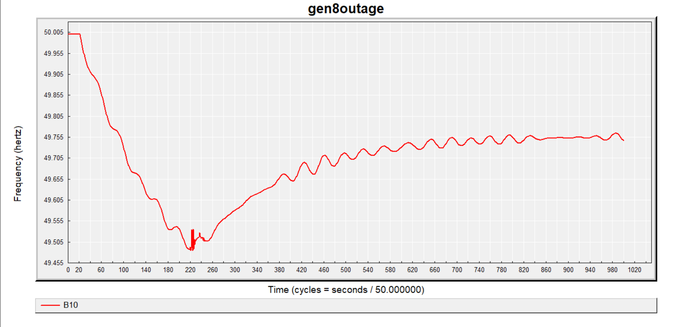

Fig: 18

Zone-1

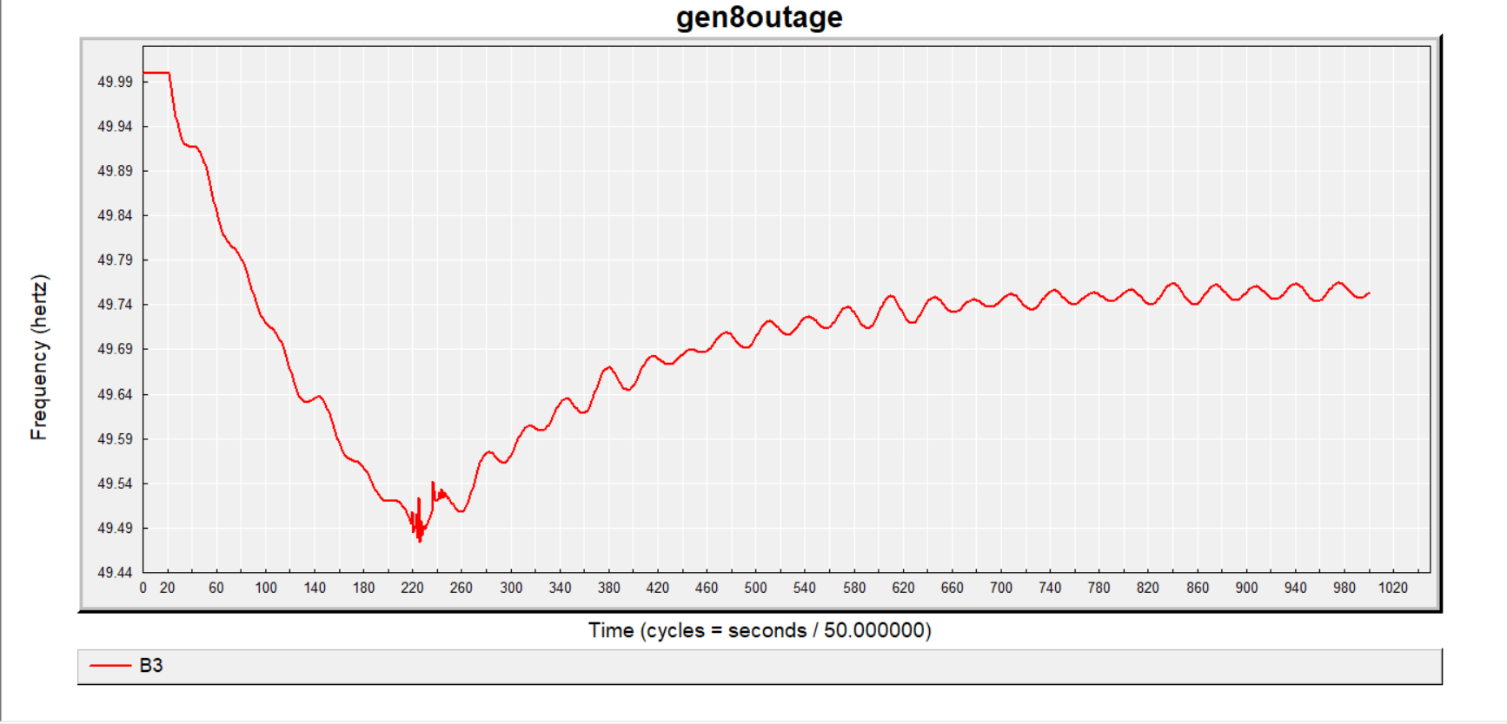

Fig :19

Zone-2

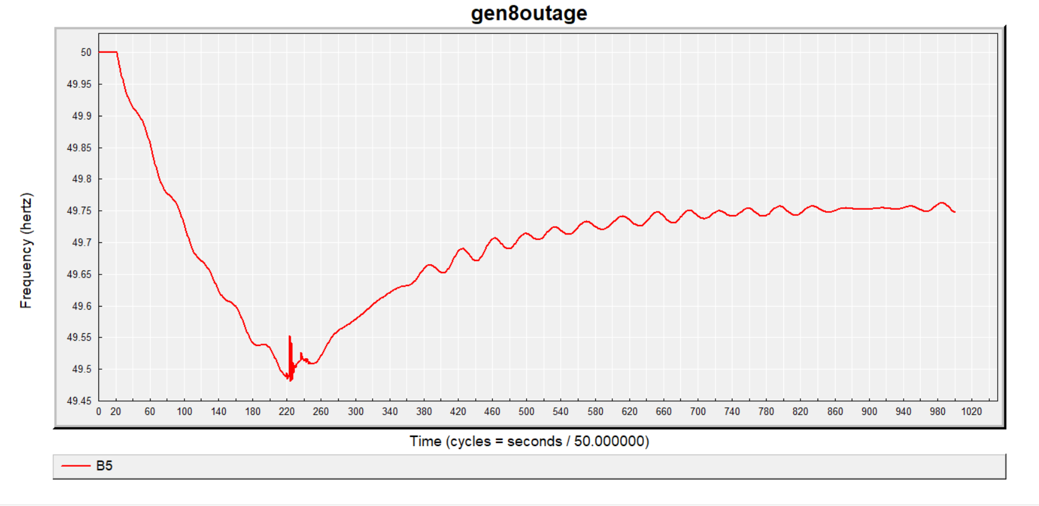

Fig: 20

Zone-3

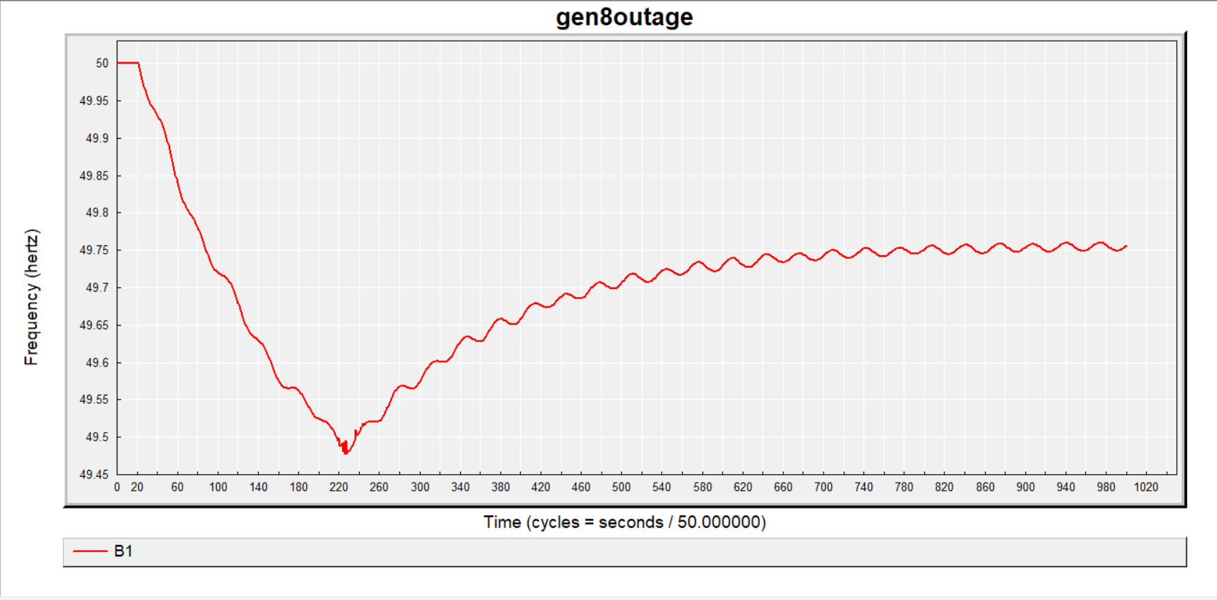

Fig: 21

Zone-4

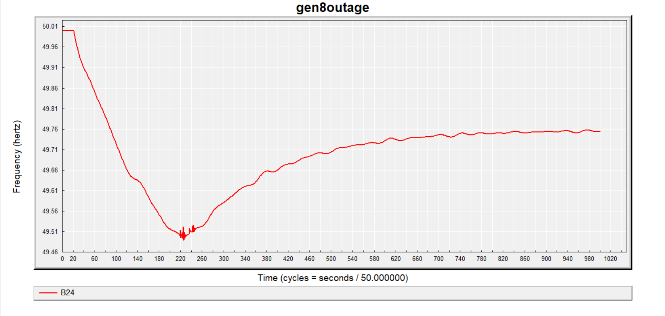

Fig: 22

### **For default load frequency relief of 8% :**

Zone-0

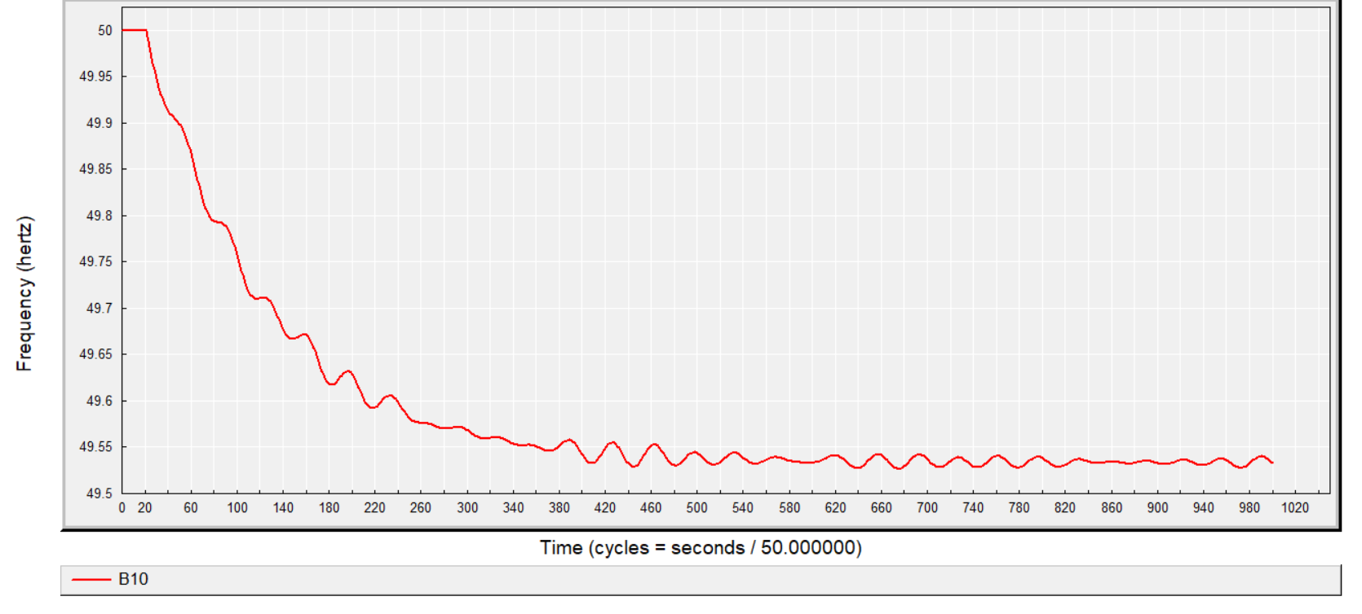

Fig: 23

Zone-1

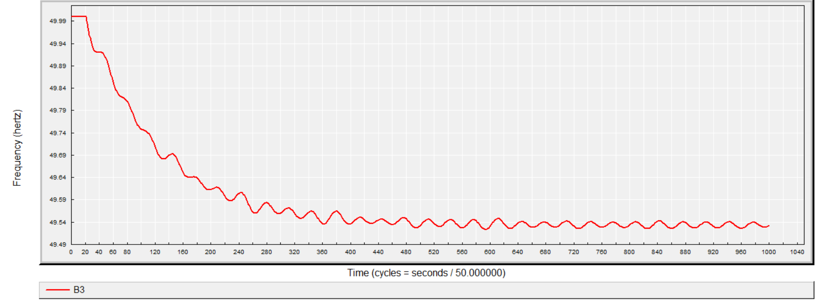

Fig: 24

Zone-2

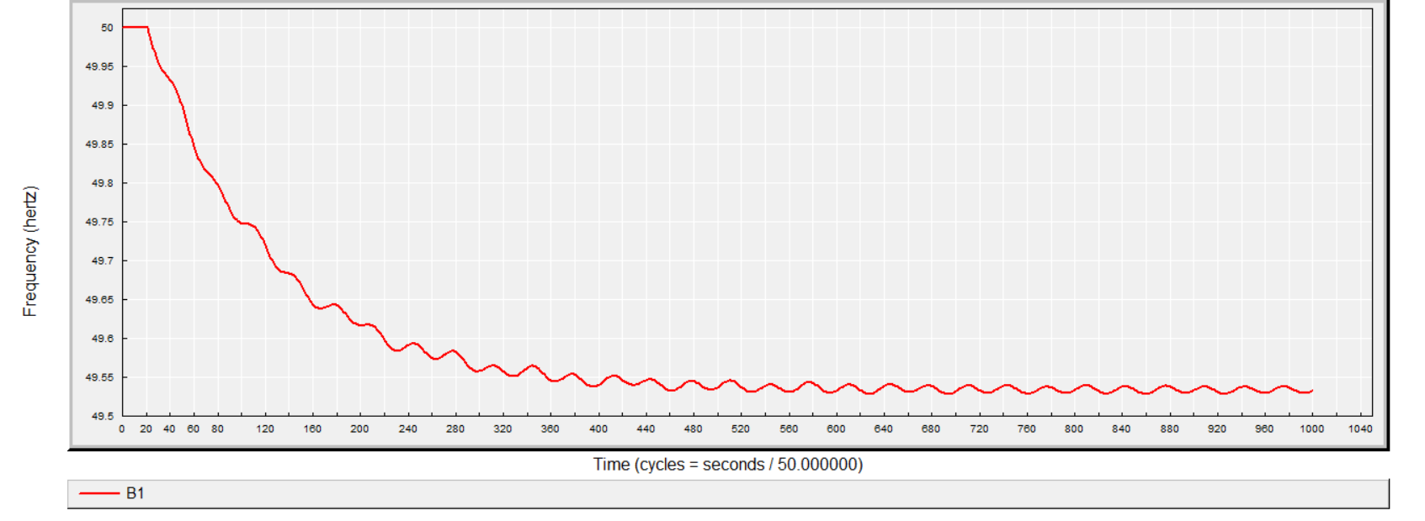

Fig: 25

Zone-3

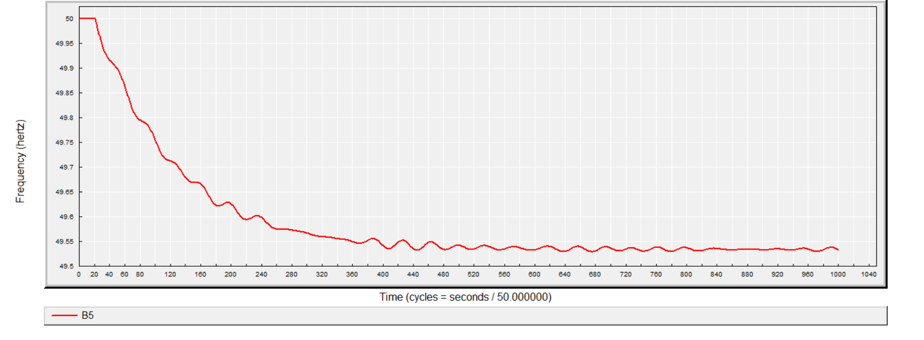

Fig: 26

Zone-4

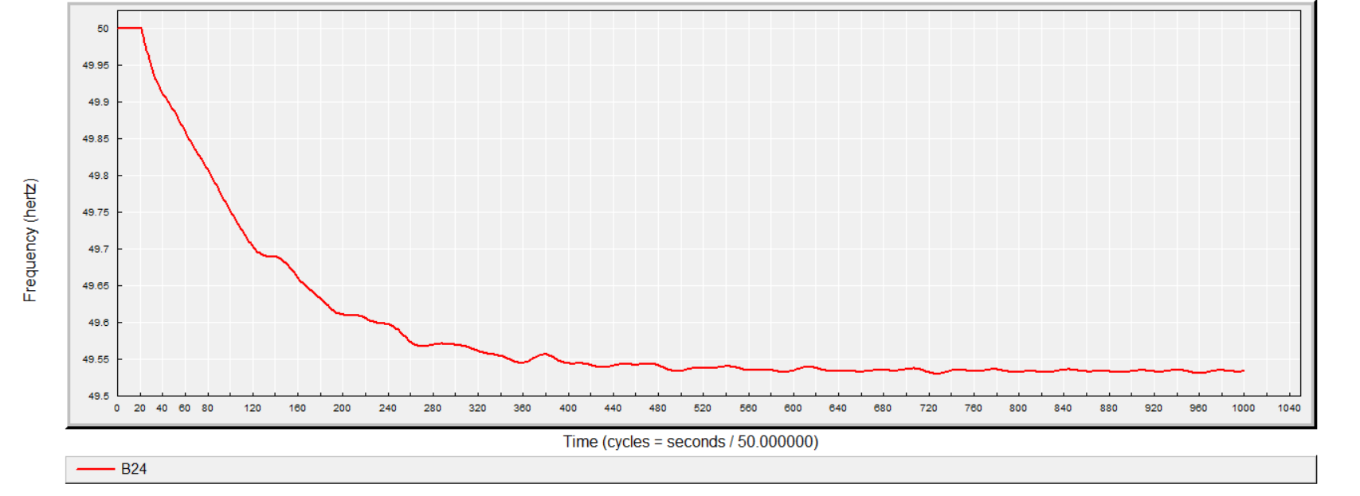

Fig: 27

### **For default load frequency relief of 10% :**

Zone-0

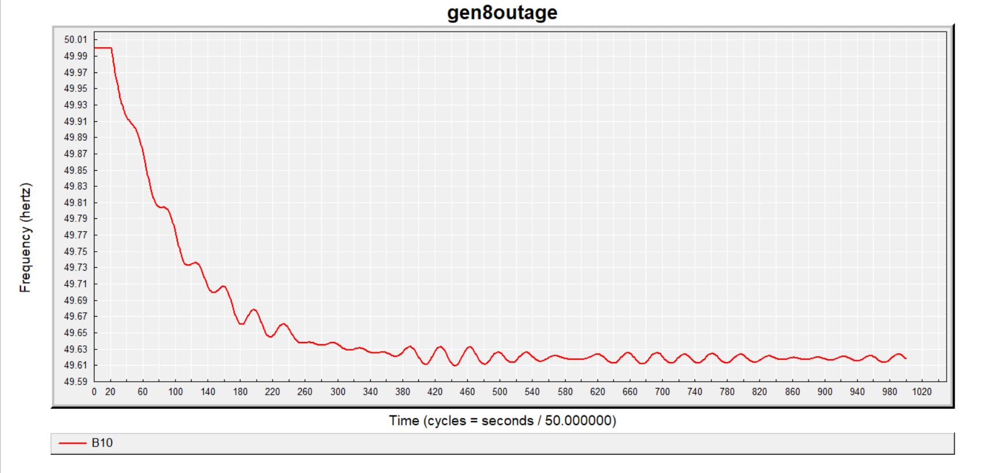

Fig: 28

Zone-1

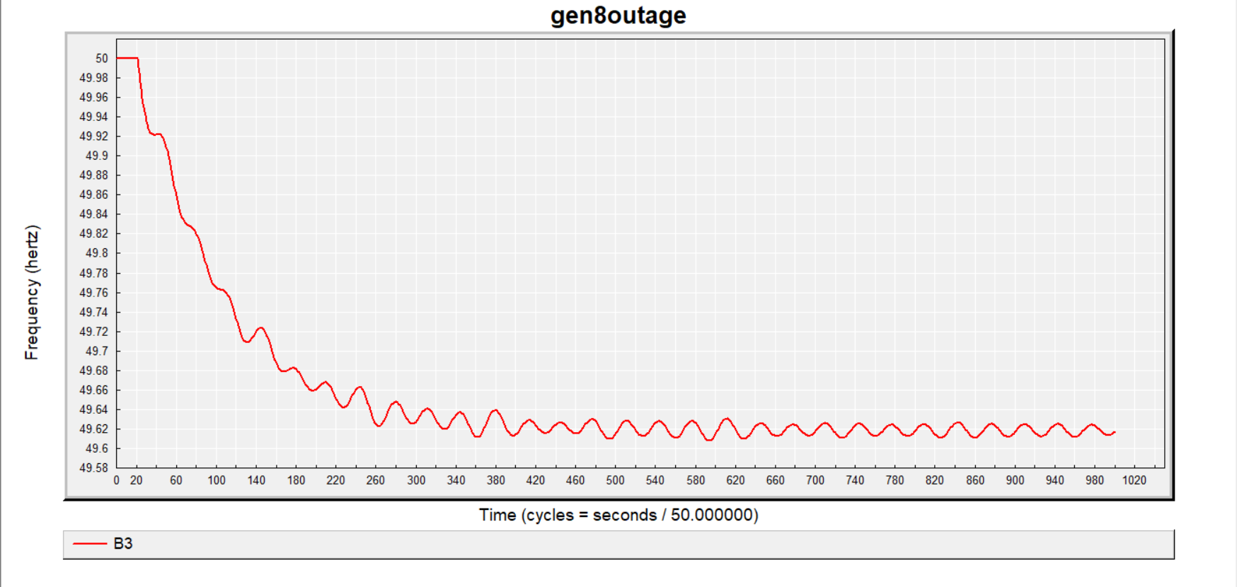

Fig: 29

Zone-2

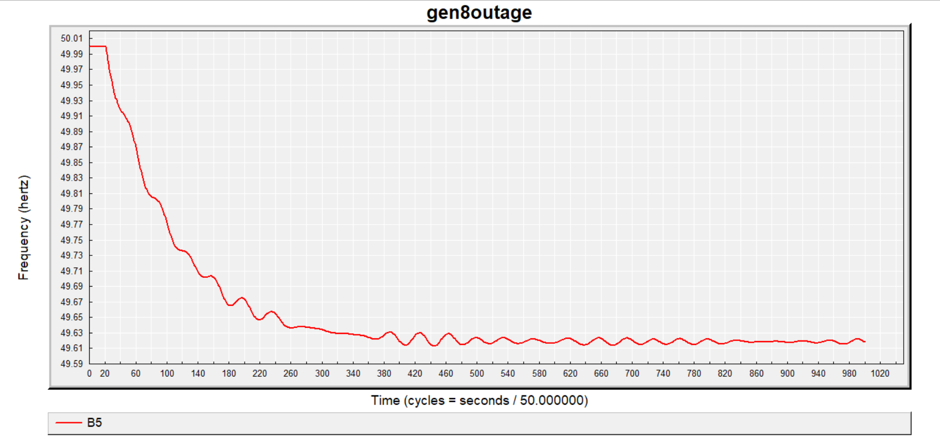

Fig: 30

Zone-3

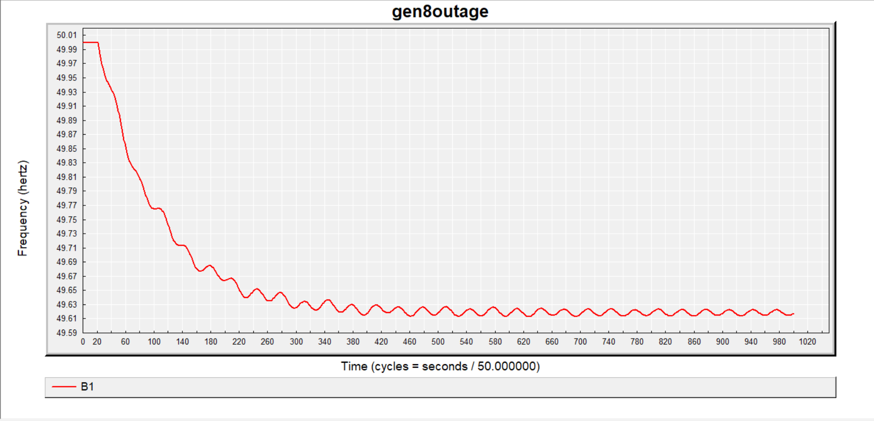

Fig: 31

Zone-4

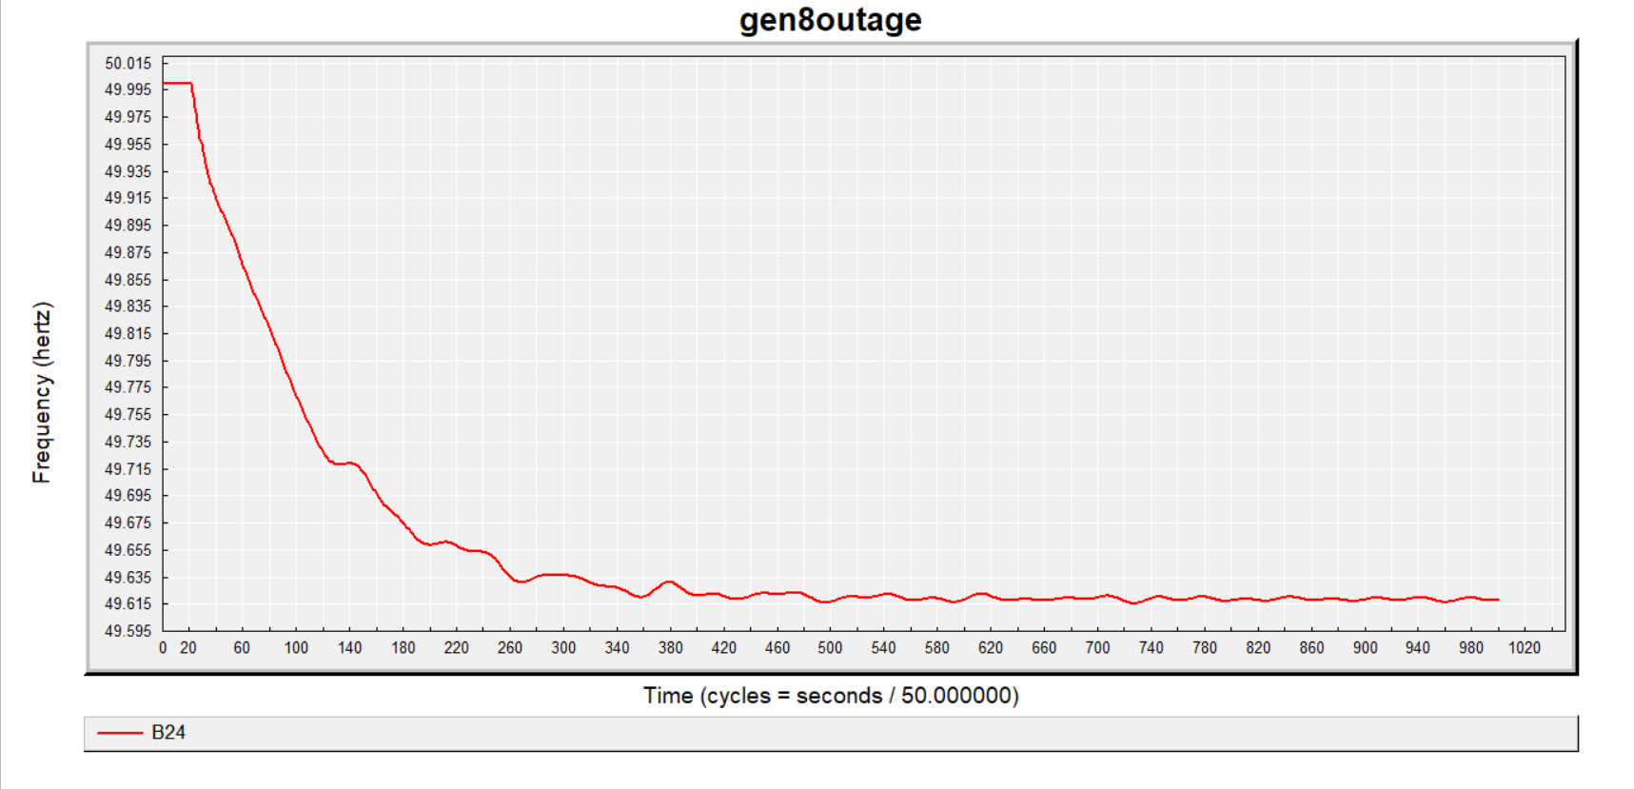

Fig: 32

# **Findings:**

We compared the suggested load shedding schemes. The load shedding schemes that were employed are:

· Under Frequency Load shed (UFLS)

· Under Frequency load shed considering load frequency relief

· Fast voltage Stability index-based load shed

· Fast voltage stability index-based load shed considering load frequency relief

In the case of the UFLS setting we used the following setting and obtained the following result for bus1.

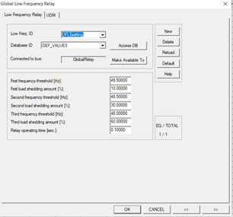

Fig: 33 (UFLS settings)

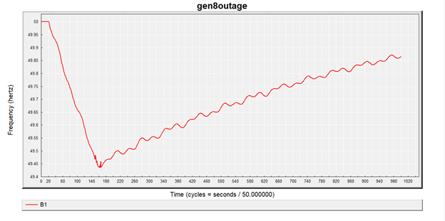

Fig: 34 (Transient response for UFLS setting and kp =0)

Here we can see that the nadir point is around 49.43 and the system frequency linearly increase after shedding the load and will reach stability after a long time.

Next, we apply UFLS settings including the effect of load frequency relief. We took the value of kp to be 1%,2%,3% respectively. This parameter can be compared with the differential operator of PID controller which helps to improve transient characteristics (i.e. reach stability faster)

For kp=1%, the nadir point was around 49.45 and the curve was less linear, which means it will reach stable conditions faster than before.

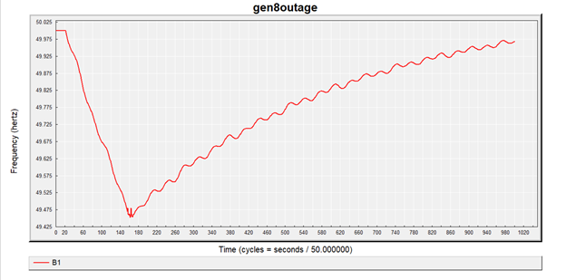

Fig: 35 (Transient response for UFLS setting and kp =1)

Similarly, we can see improvement of transient response when kp is increased further. (The graphs are attached in previous segment)

Next, we employed a load shedding scheme involving FVSI model. At first, we calculated FVSI using the given formula. We composed a MATLAB script which helped us to calculate the FVSI for each branch and using that data we divided the bus into 5 tiers:

· Teir 1 is of the most unstable buses. We put them in zone 4

· Teir 2 is comparatively less unstable than 1 but still not very strong. We put them on zone 3

· Teir 3 is somewhat strong and they are in zone 2

· Teir 4 is of strong buses and they are on zone 1

· Teir 5 are the strongest buses and these are in zone 0

Next, we employed different loadshedding percentage for these zones

|  |  |
| --- | --- |
| FVSI setting for zone 0 | FVSI setting for zone 1 |
| FVSI setting for zone 2 | FVSI setting for zone 3 |
| FVSI setting for zone 4 | |

Fig:36

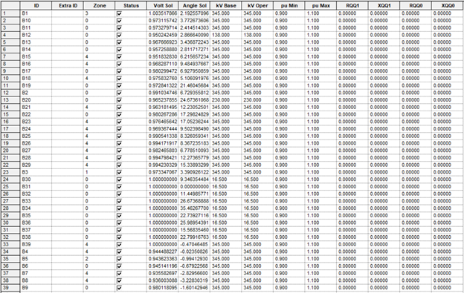

Fig: 37 (bus division for different zones)

After that we perform the transient analysis and achieve and following results. We take one bus from each zone for analysis.

|  |
| --- |
| Fig : transient response for zone 0 |
| Fig : transient response for zone 1 |
| Fig : transient response for zone 2 |
| Fig : transient response for zone 3 |
| Fig : transient response for zone 4 |

Fig: 38

From the graph we can see that the nadir point has improved significantly.

Next we employ kp with FVSI setting. For easier comparison we will take a bus from the weakest zone and compare the results

For bus 24 of zone 4 we see the results for kp=5,10 respectively.

|  |
| --- |
| Fig: transient response for zone 4 with kp 5 |
| Fig : transient response for zone 4 with kp 10 |

Fig: 39

In the first case(kp =5) the nadir point is around 49.5. as the frequency drops to 49.5, load was shed and thus frequency improved.

But in the next case of kp=10, the nadir point is above 49.5. so, the load was not even shed. This is a significant improvement.

In a nutshell, the stability of the bus improved significantly for each new load shedding scheme. If we consider the UFLS setting with kp=0 (the reference), we can see that the response with UFLS setting and increased Kp is better than the previous settings. Next when we applied the FVSI setting, significant improvement in the nadir point was seen. Including Kp settings, the bus achieves stability much faster and in some cases even load shedding was not required.

# **Conclusion:**

In our analysis of the IEEE 39-bus power system using the Newton-Raphson method for load flow analysis, we developed a load shedding model to manage frequency disturbances. The load flow analysis provided a converged solution with accurate bus voltages and power flows. We then implemented three different frequency relief settings to observe their impact on the system's nadir point and overall frequency response. The setting with highest Kp value significantly improved the system's frequency stability, demonstrating that increased frequency relief in load shedding models enhances overall power system stability by achieving better nadir points and quicker stabilization during frequency disturbances.

We then calculated the FVSI of the lines connected to each bus to basically determine the condition of the buses, and created five different zones based on the calculated values. Later we developed a load shedding scheme for these five different zones and the extent of load shedding applied was varied according to the zones. Lastly, we observed the frequency curves for the five different zones with implementation of two different load frequency relief settings in order to determine any changes involved.